S-TAG

A smart tracker for quick and easy household tracking

P Uday Bhaskar   
B.Tech.Electronics and communication   
Vellore Institute of Technology,Chennai19BEC1398Chennai, India  
udaybhaskar.p2019@vitstudent.ac.in

Aman Sahu  
B.TechElectronics and communication   
Vellore Institute of Technology,Chennai19BEC1180Chennai, India  
aman.sahu2019@vitstudent.ac.in

Naman Shandilya  
B.TechElectronics and Computer Science  
Vellore Institute of Technology,Chennai19BLC1015Chennai, India  
naman.shandilya2019@vitstudent.ac.in

***Abstract*—This paper is written on the project Smart TAG(S-Tag) which is a tracker that can track household items by sound and vibration and also displays its coordinates.**

# Introduction

Many times we misplace our things and go searching for them everywhere in the house, and after a long search, we end up finding them with much distress. Be it keys ,bags, vehicles ,briefcases, etc we lose those things very frequently. Though there are multiple projects and products that are out there most of them are rather high tech and expensive.

So one of the main issues that we students face in our daily lives is managing things like keys, bags, valuables, etc be it on the college campus or at home, or at the hostel. So the basic feature that we needed was a way to locate misplaced items in a small area.

So, in this project, we are going to build an IoT-based Smart TAG using NODE MCU, GPS module, Buzzer, Battery, etc. Now in case you can’t find your keys and you remember that you have attached a SMART TAG to your valuables, so you take out your phone and open Chrome, and open your S-tag Webpage. Then you click on the toggle button, and in moments, you hear a beep sound coming from your tag, and with this, you will get the GPS coordinates of your device and in turn, can easily track your things.

# Motivation

The idea for the project was initiated when we saw Air tag which was released by the infamous company Apple. We saw that the product had tremendous uses in our daily lives and could be used for almost anything that you can think of but as students, it was very hard for us to purchase it, as it was almost Rs 3500 which was way out of our budget. Also as students, we didn't need all of the high-level, high-tech features which were there in Air Tag.

So we thought of implementing our own S -TAG which would be affordable and would do almost all of the things in a short range of areas and in an affordable manner. It would be compact enough that it could attach to the majority of things and wouldn't make much difference.

# Block Diagram ,Circuit Diagram and UML Diagram

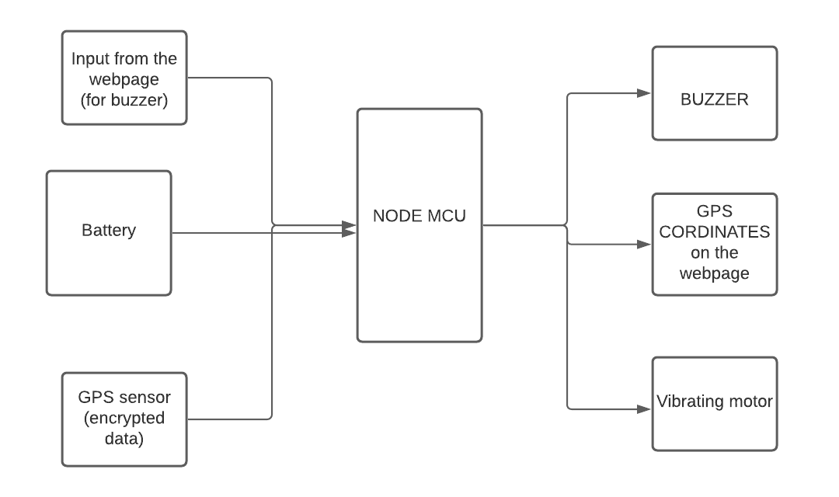

In the inputs first, we have the button from the webpage for the buzzer and vibrating motor. that input will be received by the node MCU through WiFi, and on the basis of the input, the microcontroller will switch on or switch the buzzer and vibrating motor.

Second, we have the GPS sensor which will give the NMEA(**National Marine Electronics Association)** encrypted data which will be decoded by the node MCU by using the respective library, and then the output will show on the webpage that we have created.

The third input is for the power which will be required by the node MCU.

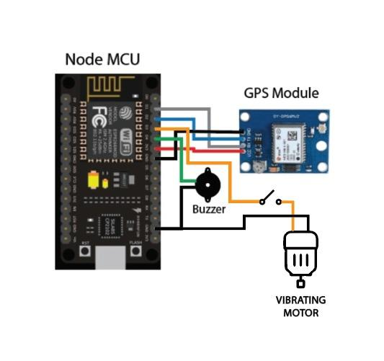

# **User Interface Specifications**

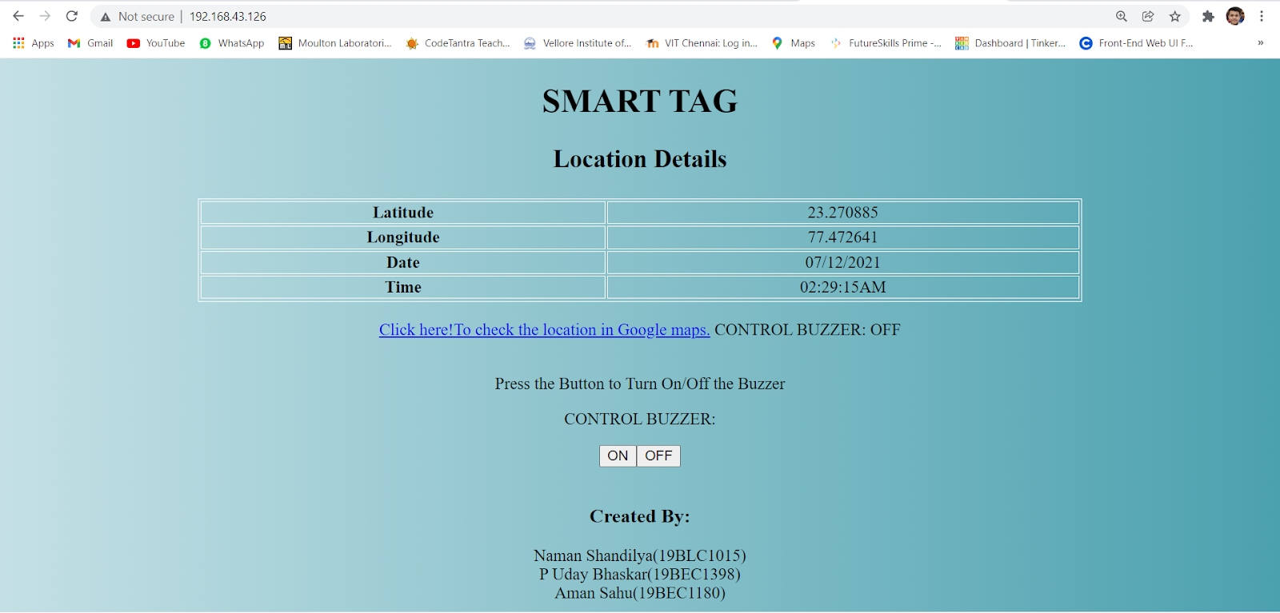

The user interface basically has a title as “SMART-TAG” , Location details, and also has a table which shows the real time Latitude, Longitude, Date and Time of the tag which is attached to the lost valuables.

We also have a google link which is connected to the Google maps which show the real time location of your lost thing, which helps users to easily navigate their things using our web page SMART-TAG.

And we also created an “ON/OFF” button to control the Buzzer and Vibrating motor to easily navigate their valuables. By that our Smart-TAG starts buzzing and vibrating wherever you lost it.

# **Software Description**

To perform the project 2 softwares were required namely Arduino IDE and VS Code. Arduino IDE was used to code and upload the program to the Node Mcu and Vs code was used to Code the HTML Webpage.

Arduino IDE

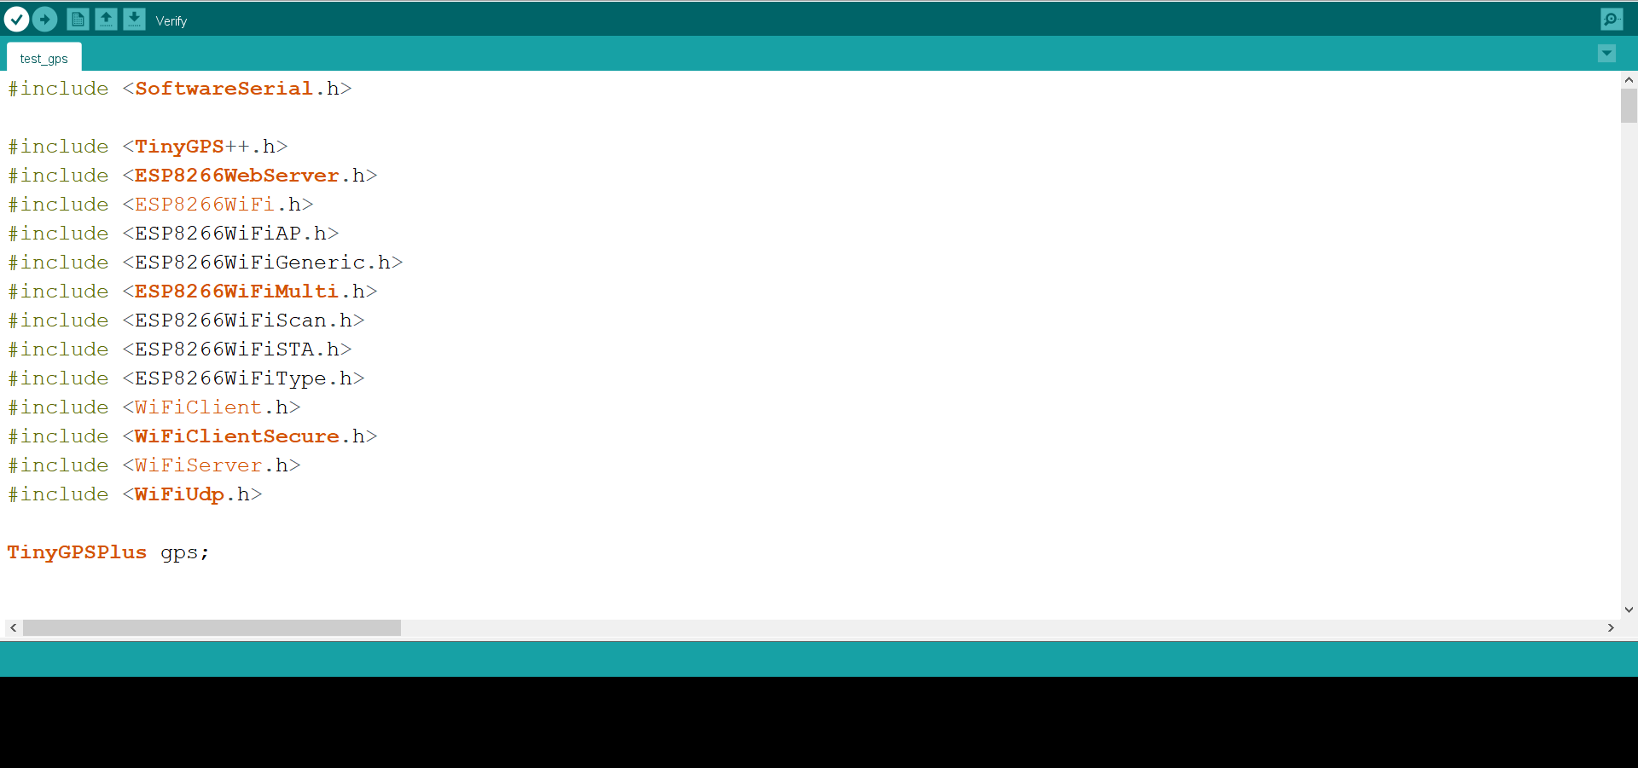

VS Code

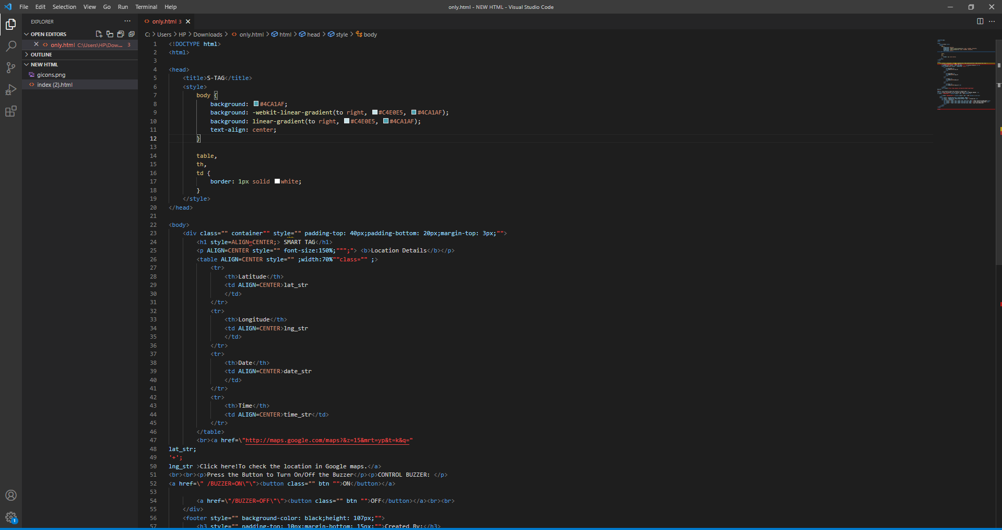

# **Hardware Description.**

1. NodeMCU**:** NodeMCU is a low-cost open source IoT platform. It initially included firmware which runs on the ESP8266 Wi-Fi SoC from Express if Systems, and hardware which was based on the ESP-12 module. Later, support for the ESP32 32-bit MCU was added.

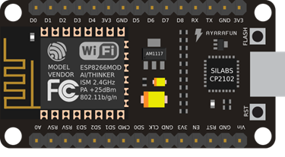

**2.** Buzzer:A buzzer or beeper is an audio signalling device, which may be mechanical, electromechanical, or piezoelectric (piezo for short). Typical uses of buzzers and beepers include alarm devices, timers, and confirmation of user input such as a mouse click or keystroke.

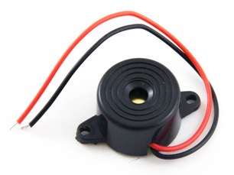

**3.** GPS Module**:**The Global Positioning System (GPS) is a satellite based navigation system that provides location and time information. GPS is nowadays widely used and also has become an integral part of smart phones.

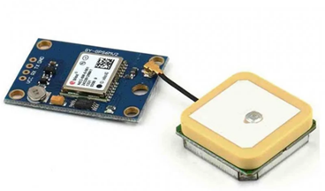

4. Vibrating Motor**:**Vibration motor is a compact size coreless DC motor used to informs the users of receiving the signal by vibrating, no sound. Vibration motors are widely used in a variety of applications including cell phones, handsets, pagers, and so on.

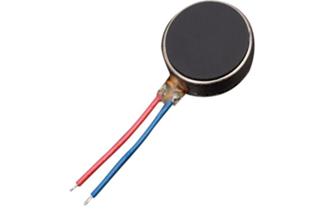

# Testing Procedures

There are 3 main parts in the project namely gps module,node mcu and buzzer.

The main testing of the project was done on a breadboard and all the individual sensors were tested for any faults and the input and outputs.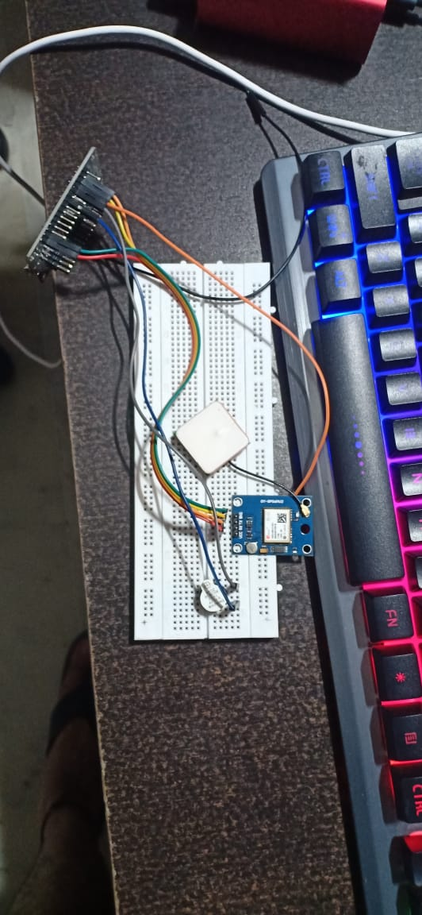

After that all the components have been implemented on the Zero PCB.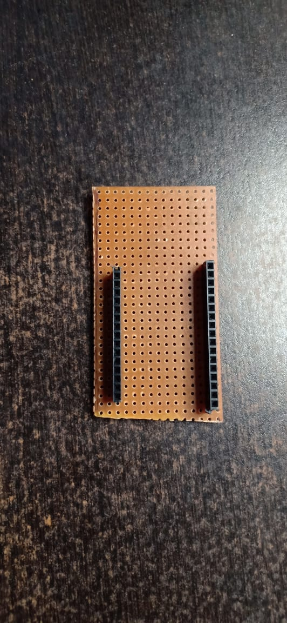

# Project Implementation

This is the hardware implementation of the project on a zero PCB.

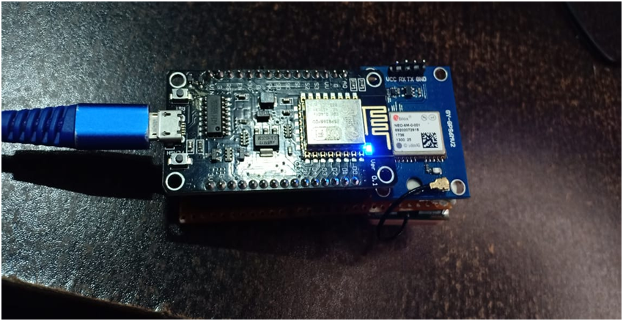

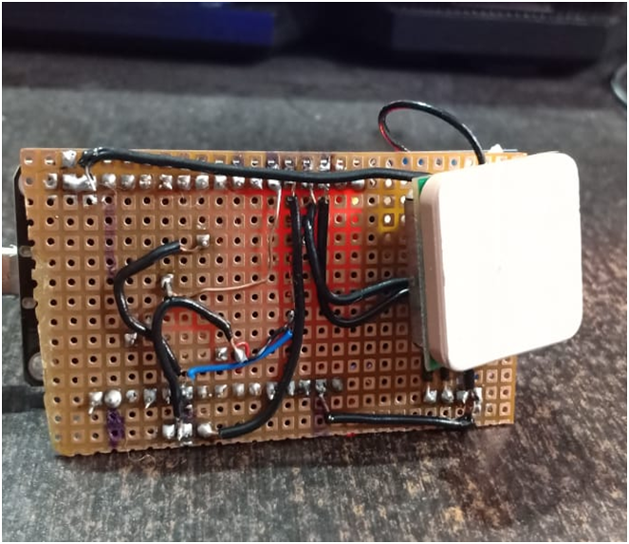

# Result

We were able to implement S-Tag successfully, with complete functioning. Also we were well within our budget and tried to make use of the components that we have to the fullest.

This S-tag can be used in various applications such as valuable tracking, key tracking, backpack tracking, vehicle tracking, person tracking etc. the implementations and the uses can be different according to different situations.

##### References

W. A. Jabbar et al., “Design and Fabrication of Smart Home With Internet of Things Enabled Automation System,” IEEE Access, vol. 7, pp. 144059–144074, 2019.

Z. Wan, Y. Song, and Z. Cao, “Environment Dynamic Monitoring and Remote Control of Greenhouse with ESP8266 NodeMCU,” in 2019 IEEE 3rd Information Technology, Networking, Electronic and Automation Control Conference (ITNEC), Chengdu, China, 2019, pp. 377–382.

Gannavaram V, Tulasi Krishna & Gannavaram, Venkat Praveen & Gannavaram, Venkat Chinmai Sai & Reddy, G. & Prabhakar, Girija & Kama, Ramudu & Budda, Jagadish & Rao, Vadithala & Vuppu, Shankar & Laxman, Srinivas & Bushan, Phridviraj & Pratapagiri, Sreenivas & Kolluri, Johnson. (2021). SOLAR PARK MONITORING AND FAULT DETECTION SYSTEM USING IOT AND MACHINE LEARNING.

Gannavaram V, Tulasi Krishna & Gannavaram, Venkat Praveen & Gannavaram, Venkat Chinmai Sai & Rao, Vadithala & Reddy, G. & Polala, Niranjan & Pakala, Shireesha & Madugula, Sujatha & Madupu, Ram & Rangu, Seshu & Saideep, Sunkari & Kandhikonda, Uma & Gannavaram, Srivani. (2021). AI and IoT enabled Smart Medicine Box.

Gannavaram V, Tulasi Krishna & Gannavaram, Venkat Praveen & Gannavaram, Venkat Chinmai Sai & Angatha, V. & Merugu, Shyamsunder & Saideep, Sunkari & Kandhikonda, Uma & Ette, Arun Reddy & Bejgam, Rahul & Keshipeddi, Sai & Dunde, Venu & Srinivas, Azmeera & Gannavaram, Srivani. (2021). IoT and Machine Learning based Power Generation from Sewage Water.

M. Muniraj, A. R. Qureshi, D. Vijayakumar, A. R. Viswanathan, and N. Bharathi, “Geotagged internet of things (iot) device for radiation monitoring,” in 2017 International Conference on Advances in Computing, Communications and Informatics (ICACCI), Udupi, 2017, pp. 431–436.

H. Aamer, R. Mumtaz, H. Anwar, and S. Poslad, “A Very Low Cost, Open, Wireless, Internet of Things (IoT) Air Quality Monitoring Platform,” in 2018 15th International Conference on Smart Cities: Improving Quality of Life Using ICT & IoT (HONET-ICT), Islamabad, 2018, pp. 102–106.

K. Sangsanit and C. Techapanupreeda, “NodeMCU Choreography Automation by CoAP,” in 2019 International Conference on Information Networking (ICOIN), Kuala Lumpur, Malaysia, 2019, pp. 350–353.

T. K. Gannavaram V, U. Maheshwar Kandhikonda, R. Bejgam, S. B. Keshipeddi and S. Sunkari, "A Brief Review on Internet of Things (IoT)," 2021 International Conference on Computer Communication and Informatics (ICCCI), 2021, pp. 1-6, doi: 10.1109/ICCCI50826.2021.9457009.

T. K. Gannavaram V, U. M. Kandikonda, R. Bejgam, S. B. Keshipeddi and S. Sunkari, "A Brief Review on Internet of Things (IoT)," 2021 International Conference on Computer Communication and Informatics (ICCCI), 2021, pp. 1-6, doi: 10.1109/ICCCI50826.2021.9451163.

Tummanapally, Shraddha Shree and Sunkari, Saideep, Smart Vehicle Tracking System using GPS and GSM Technologies (July 12, 2021). Available at SSRN: https://ssrn.com/abstract=3884903 or http://dx.doi.org/10.2139/ssrn.3884903